CMS POINTS

Makeup result Faculty portal side remove the field Sr.No and adjust the remaining because some field are not showing on screen. Also error on submission of result.
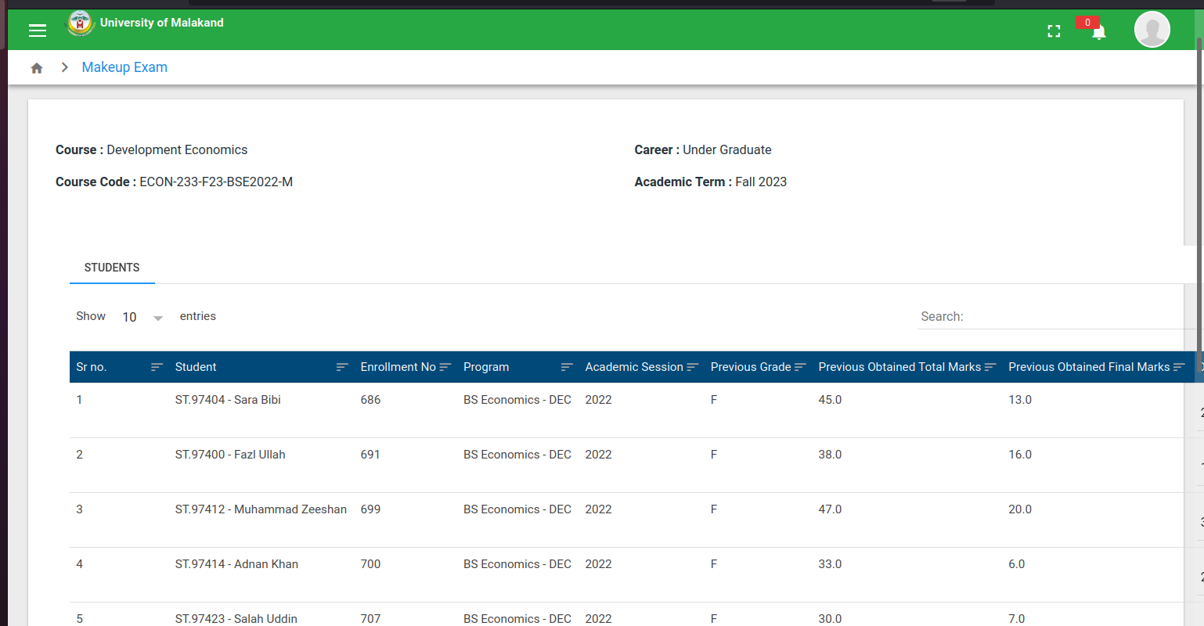
Field going outside of the srceen
Error on result submission

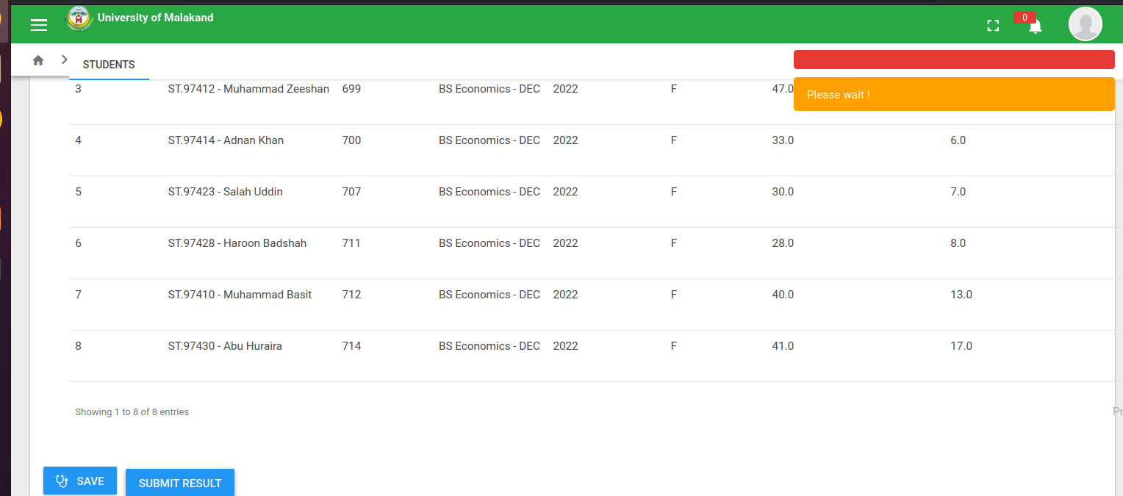

Error in DBS when HOD approve Results.

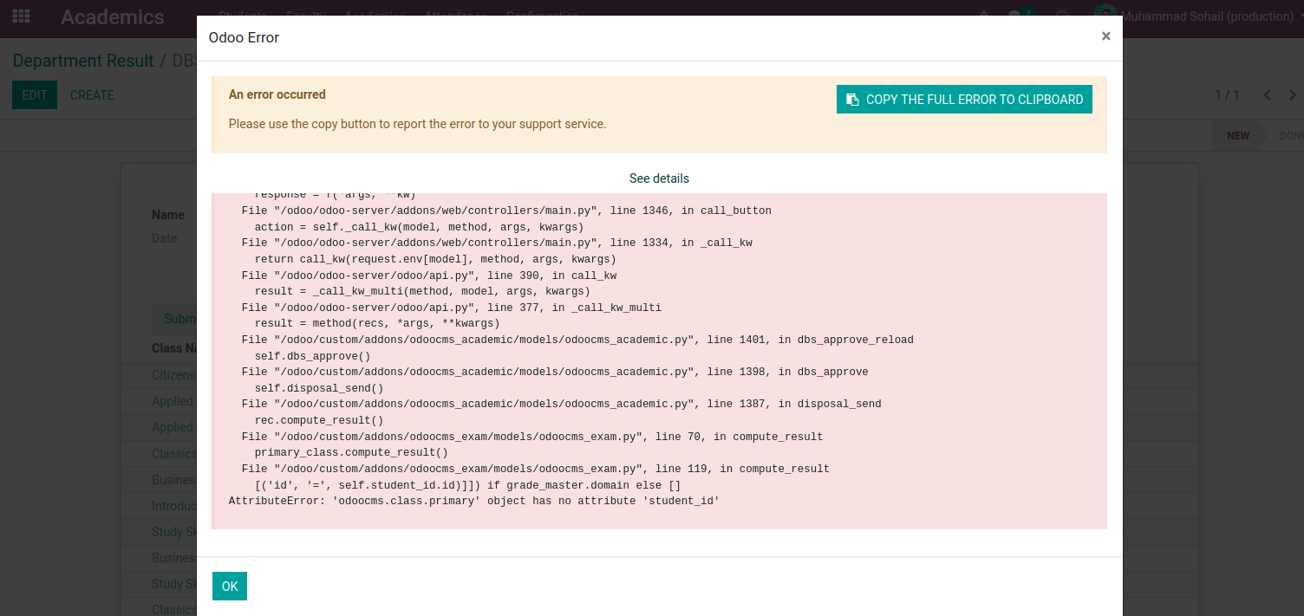

Grading system not update. System assign grades on old scheme.

